1. Consider a case, a folder has multiple files and how would copy it to destination machine path (Try using SCP, cp options in Linux)

scp -r ~/linux_practice kamalavalli@10.0.2.15:/home/kamalavalli/backup

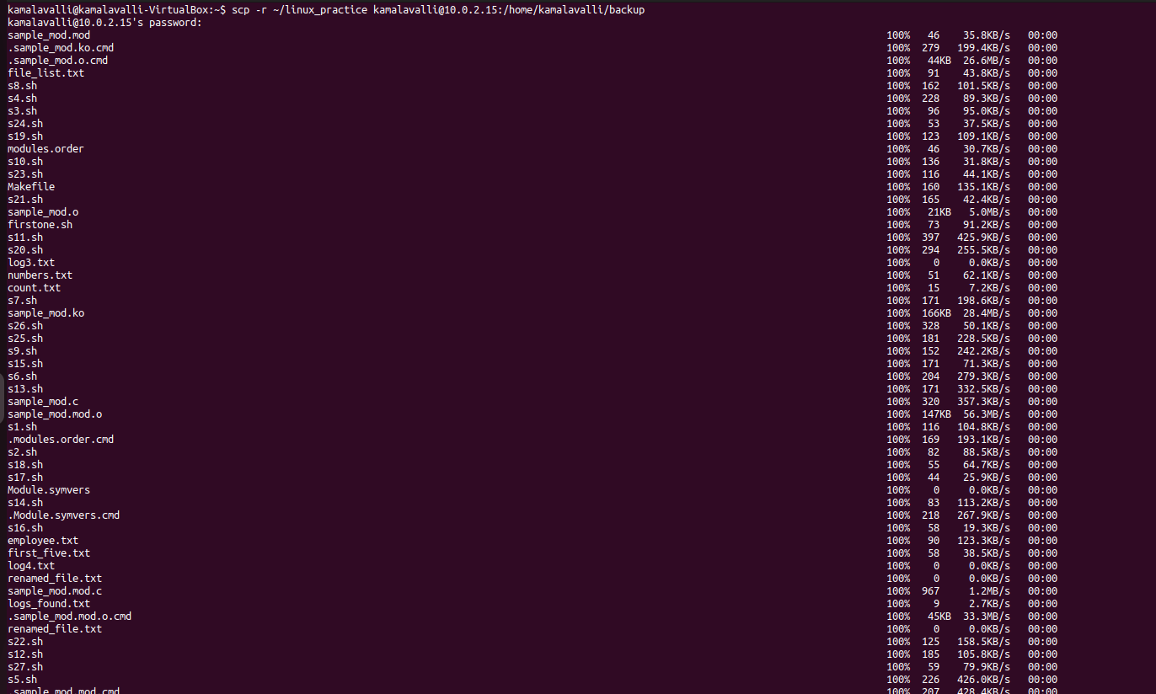

cp -r ~/linux_practice /home/kamalavalli/backup

